**3. Create a HTML page make a quiz game where user should answer one question at a time, answers must be shown in radio buttons. Without submitting the answer, quiz should not move to next question (Minimum five questions must be there). When user wishes to get score (using score button) score should be displayed in alert message. All the question must be loaded in same page (no page navigation is allowed) Sample screen shot:**

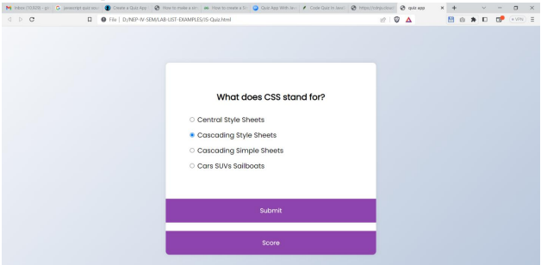

**HTML CODE:**

<!Doctype html>

<html>

<head>

<link rel="stylesheet" href="quizstyles.css"/>

<title>Quiz app</title>

</head>

<body>

<div class="quiz-container" id="quiz">

<div class="quiz-header">

<h2 id="question">Question is loading..</h2>

<ul>

<li><input type="radio"name="answer" id="a" class="answer"/>

<label for="a" id="a_text">Answer...</label></li>

<li><input type="radio"name="answer" id="b" class="answer"/>

<label for="b" id="b_text">Answer...</label></li>

<li><input type="radio"name="answer" id="c" class="answer"/>

<label for="c" id="c_text">Answer...</label></li>

<li><input type="radio"name="answer" id="d" class="answer"/>

<label for="d" id="d_text">Answer...</label></li>

</ul>

</div>

<button id="submit">Submit</button>

<br/>

<button id="score">Score</button>

<br/>

</div>

<script src="app.js"></script>

</body>

</html>

**CSS CODE:**

*{

box-sizing:border-box;

}

body{

background-color:#b8c6db;

background-image:linear-gradient(314deg,#b8c6db 0%,#f5f5fa 100%);

font-family:"Poppins",sans-serif;

display:flex;

align-items:center;

justify-content:center;

height:100vh;

overflow:hidden;

margin:0;

}

.quiz-container{

background-color:#fff;

border-radius:10px;

box-shadow:0 0 10px 2px rgba(100,100,100,0.1);

width:600px;

max-width:95vw;

overflow:hidden;

}

.quiz-header{

padding:4rem;

}

h2{

padding:1rem;

text-align:center;

margin:0;

}

ul{

list-style-type:none;

padding:0;

}

ul li{

font-size:1.2rem;

margin:1rem 0;

}

ul li label{

cursor:pointer;

}

button{

background-color:#8e44ad;

color:#fff;

border:none;

display:block;

width:100%;

cursor:pointer;

font-size:1.1rem;

font-family:inherit;

padding:1.3rem;

}

button:hover{

background-color:#732d91;

}

button-focus{

outline:none;

background-color:#5e3370;

}

**JAVASCRIPT CODE:**

const quizData = [{

question: "Which language runs in a web browser?",

a: "java",

b: "C",

c: "Python",

d: "Javascript",

correct: "d",

}, {

question: "What does CSS stand for?",

a: "Central style sheets",

b: "Cascading style sheets",

c: "Cascading simple sheets",

d: "Cars SUVs sailboats",

correct: "b",

}, {

question: "What does HTML stand for?",

a: "Hyper Text Markup language",

b: "Hyper Markdown language",

c: "Hyper Machine language",

d: "Helicopter terminals motorboats lamborgins",

correct: "a",

}, {

question: "What year was JavaScript launched?",

a: "1996",

b: "1995",

c: "1994",

d: "none of the above",

correct: "b",

}, {

question: "What does SVG stands for?",

a: "Scalar vector graphic",

b: "Scale vector graphic",

c: "solar vector graphic",

d: "none of the above",

correct: "a",

}];

const quiz = document.getElementById("quiz");

const answerElements = document.querySelectorAll(".answer"); // Corrected typo from querySelctorAll to querySelectorAll

const questionElement = document.getElementById("question");

const a_text = document.getElementById("a_text");

const b_text = document.getElementById("b_text");

const c_text = document.getElementById("c_text");

const d_text = document.getElementById("d_text");

const submitButton = document.getElementById("submit");

const scoreButton = document.getElementById("score");

let currentQuiz = 0;

let score = 0;

const deselectAnswers = () => {

answerElements.forEach((answer) => (answer.checked = false)); // Changed answer.checked=false to answer.checked = false

};

const getSelected = () => {

let answer;

answerElements.forEach((answerElement) => {

if (answerElement.checked)

answer = answerElement.id;

});

return answer;

};

const loadQuiz = () => {

deselectAnswers();

const currentQuizData = quizData[currentQuiz];

questionElement.innerText = currentQuizData.question;

a_text.innerText = currentQuizData.a;

b_text.innerText = currentQuizData.b;

c_text.innerText = currentQuizData.c;

d_text.innerText = currentQuizData.d;

};

loadQuiz();

submitButton.addEventListener("click", () => {

const answer = getSelected();

if (answer) {

if (answer === quizData[currentQuiz].correct) score++;

currentQuiz++;

if (currentQuiz < quizData.length) loadQuiz();

else {

quiz.innerHTML = `<h2>You answered ${score}/${quizData.length} questions correctly</h2>

<button onclick="disScore();">Score</button><br>

<button onclick="history.go(0)">Play Again</button>`;

}

}

});

scoreButton.addEventListener("click", () => {

window.alert("Your score till now is:" + score * 10);

});

function disScore() {

window.alert("Your final is:" + score * 10);

}